**ECOSOLAR: ENHANCING RENEWABLE ENERGY WITH DUST DETECTION**

S.VISHNU VARDHAN  
Department of Data Science and Business System *SRM Institute of Science and Technology*Kattankulathur,Tamil Nadu  
sv4213@srmist.edu.in

==

AKETI SAI MANOHARA NAVEEN  
Department of Data Science and Business System *SRM Institute of Science and Technology*Kattankulathur,Tamil Nadu  
as8234@srmist.edu.in

VECHALAPU KANAKA DURGA PRASAD  
Department of Data Science and Business System *SRM Institute of Science and Technology*Kattankulathur,Tamil Nadu  
vd0810@srmist.edu.in

ANNA ANBUMOZHI(Guide)  
Department of Data Science and Business System *SRM Institute of Science and Technology*Kattankulathur,Tamil Nadu  
annaa2@srmist.edu.in

RANJITH KUMAR GOVINDASU  
Department of Data Science and Business System *SRM Institute of Science and Technology*Kattankulathur,Tamil Nadu  
rg0126@srmist.edu.in

*Abstract-*Solar panels are a cornerstone of renewable energy initiatives, but their efficiency is significantly hampered by dust accumulation, which blocks sunlight and diminishes energy output. To address this issue, we propose Automated Dust Detection System Leveraging Deep Learning Techniques (ADDS-DL). Our solution employs the VGG16 “Convolutional Neural Network” (CNN), known for its high accuracy in image classification, utilizing its deep architecture for detailed feature extraction to effectively differentiate between clean and dusty solar panels. Developed with the TensorFlow framework, our model ensures efficient and reliable operation, capable of processing extensive image data with precision. Trained on a comprehensive dataset of solar panel images under various dust conditions, the model exhibits robust classification capabilities. This automated system reduces the need for manual inspections, maintaining solar panel efficiency and supporting continuous performance. Our approach not only enhances operational efficiency but also aligns with sustainable energy goals, ensuring optimal solar panel performance and contributing to a greener future.

*Keywords — Renewable systems, Classification Fault detection, Convolutional Neural Networks (CNN), VGG16, VGG19, VGG13 Pre-Trained networks.*

*.*

**I. INTRODUCTION**

In light of the critical imperative to attain net-zero carbon emissions globally by 2050, the energy landscape is undergoing a transformative transition from conventional hydrocarbon power generation to renewable sources. Among the most promising renewable energies, wind, hydroelectric power, and solar stand out at the top. Photovoltaic energy, harnessed through solar panels, emerges as a clean and abundant resource with a low environmental impact. However, due to many reasons, solar panel deployment is susceptible to various operational issues, ranging from broken glass and dust accumulation, adversely affecting their efficiency.

Previous research works have delved into fault detection using intelligent algorithms, including convolutional neural networks. The authors applied the techniques of CNN to detect problems in photovoltaic cells. The study provided a feature classification and extraction method on a deep two-dimensional (2D) CNN. However, it’s always been challenging to determine the most effective classifiers due to the dependence on various parameters such as input characteristics, network architecture, etc. This existing system employs two distinct deep-learning architectures, namely VGG16. The algorithm initially categorizes input thermal images into six different classes in both models. Subsequently, pre-trained VGG16 CNN model is imported. Following this, pooling, dropout, and Sigmoid layers are incorporated into the models. Ultimately, fine-tuning is applied to enhance the performance of the models.

# VGG16 is convolutional neural networks widely employed for image classification. The key distinction between these two architectures lies in the number of layers; VGG16 comprises 16 layers. Both architectures have demonstrated state of the art performance on various benchmark datasets, including ImageNet. They are favored choices due to their versatility, accuracy, and efficiency compared to other techniques. Moreover, this Proposed system is suitable for transfer learning, a technique enabling the utilization of a pre-trained model to enhance the performance of a new model, especially when dealing with a small dataset for the new model. Considering these factors, our proposed work aims to advocate for an efficient and accurate fault detection system using the CNN VGG16 model designed to detect six fault classes.

**Paper Organization**

The brief record of our project “ECOSOLAR: ENHANCING RENEWABLE ENERGY WITH DUST DETECTION” contains all aspects of the project implementation and future work to be done to the system like

1) **Title:** Title of the project.

2) **Abstract:** A brief summary of the paper, outlining the problem, solution approach, methodology, and key findings.

3) **Keywords:** Relevant terms such as "Solar Panel", "Dust Detection", "CNN", "Image Processing", "VGG16", etc.

4) **Introduction:** Briefly introduce the problem of dust accumulation on solar panels and its impact on performance. State the purpose and motivation of the project.

5) **Literature Survey:** Reviewing all the previous projects done on our project and finding if any helpful.

6) **Methodology:** Given our proposed methodology and modeling of our project.

7) **Architecture:** Featured our proposed and used algorithm for implementing our project.

8) **Results and Discussion:** Present the results of the project, including test cases or experiments conducted. Use graphs, tables, and images to show the performance of the dust detection system. Compare the proposed method's efficiency with existing methods.

9) **Conclusion and Future work:** Summarize the project outcome and its contributions. Mention future improvements or potential applications.

10) **References:** The all papers, books, or resources used to support the study.

# **II . LITERATURE SURVEY**

Seung Heon Han and colleagues [5] presented a deep learning method for detecting faults in solar panels. Their system uses a drone (UAV) equipped with a thermal camera and GPS to capture thermal images and pinpoint faulty areas in the panels. For fault detection, they utilized an enhanced version of the YOLOv3-tiny deep learning model. The gathered data is then transmitted to a remote server via long-term evolution (LTE) for real-time visualization.

Zhendong Huang et.al. [1] proposed an efficient method for fault diagnosis for solar panels using a convolutional neural network (CNN). This method involves a two-step solution: solar panel location and classification of defects. The edge detection component, named ESPED, is based on a lightweight CNN architecture and is designed for real-time applications. Finally, the proposed approach is evaluated on infrared images collected from different photovoltaic plants, demonstrating its effectiveness in fault diagnosis.

Mary Pa et.al. [8] designed a fault detection scheme for photovoltaic solar panels using a convolutional neural network (CNN). The proposed CNN model achieves a good accuracy of 91.2% for binary classification that is normal and faulty, and 88.6% for multi-classification of 4 classes i.e., normal, cracked, dusty, and shadowed. CNN surpasses a prior model’s performance on the identical dataset, achieving a 16% improvement for binary classification and an 18.6% enhancement for multi-class classification. The research additionally investigates the consequences of decreasing the layer count and assesses the effectiveness of pre-trained models, revealing their constraints to this particular dataset.

Himanshu Bendale et.al. [7] developed a deep learning-based methodology for solar panel dust detection using CNN. The system processes thermal images captured by unmanned aerial vehicles equipped with infrared sensors. The CNN model achieves a high accuracy of 97.5% in detecting various types of faults, surpassing previous methods using principal component analysis and kullback-leibler divergence (KLD). The system considers voltage current values to predict the amount of energy loss due to defects. The proposed model demonstrates superior performance, handling multiple fault types and providing a robust solution for real-time solar panel maintenance.

Nikhil Prajapati et.al. [9] introduced a real-time method for detecting and identifying faults in photovoltaic modules using thermal images. The proposed approach employs a convolutional neural network-based algorithm, specifically You Only Look Once (YOLO), to detect and classify four types of faults. They are temporary hotspot, permanent hotspot, bypass diode, and crack/wear and tear. The study uses a dataset thermal image captured by a drone, and the results indicate reliable fault detection with a maximum mean average precision of 83.86%. However, the model’s precision could be further improved with an increased dataset, especially for bypass diode faults.

Monica Patil et.al. [6] proposed an automatic fault detection and localization method for solar photovoltaic (PV) systems. Utilizing MATLAB/Simulink and hardware experiments with a 3*3 solar panel configuration, the approach compares residual faults to a threshold value, effectively identifying and locating faults between lines within a solar rooftop string. The study focuses on cross-string and intra-string faults which are very challenging to detect with conventional protection devices in large scale PV systems. Experimental results, including led-based visual indicators, demonstrate the method’s accuracy and effectiveness in real-time fault monitoring PV systems.

Kamal and Ferrah’s work on dust detection on solar panels is built on the feature extraction utilizing the grey level co occurrence matrix system. In their research work, they describe a method for computer vision-based dust identification. Following the preprocessing stage, Hue layer characteristics from the HSV color space are recovered by employing the grey level co-occurrence matrix. Next, linear classification is used to categorize the panels as clean and dirty panels. After that, high identification rates for the tested images are provided by the suggested method [7].

A comprehensive study for solar panel fault detection using VGG16 and VGG19 CNN’s by Asif Mahmud, Md.Shamsur Rahman Shishir,Rifat Hasan, Mushifiqur Rahman(2023). Drone-Based Imaging for Fault Detection. CNN-Based Fault Classification. Integration of Thermography with Telemetry.

**III. METHODOLOGY**

The accumulation of dust on solar panels significantly reduces their efficiency by obstructing sunlight, leading to decreased energy output. Traditional methods of monitoring and cleaning solar panels are often inefficient, either relying on routine schedules that may not align with actual dust accumulation or requiring manual inspections that are labor-intensive and costly. This project aims to develop an effective automated dust detection system using the VGG16 Convolutional Neural Network model to accurately finding and quantify dust levels on solar panels from image data. The goal is to create a solution that can operate in real-time, with high accuracy and robustness to varying environmental conditions, enabling proactive and optimized maintenance scheduling to maximize energy production and reduce operational costs. The system should be scalable, adaptable to different solar panel installations, and capable of integrating with existing solar energy monitoring frameworks.

Solar panels are crucial for renewable energy and sustainability. Dust accumulation obstructs sunlight and reduces their energy output.

Dust buildup not only impacts efficiency but also increases maintenance costs and efforts. Addressing this issue is essential for optimal panel performance.

An automated dust detection system is proposed to ensure solar panels operate efficiently. This solution leverages advanced deep learning techniques.

The approach utilizes the VGG16 Convolutional Neural Network (CNN). VGG16 is known for its high accuracy in image classification and detailed feature extraction.

The system was developed using the TensorFlow framework. TensorFlow provides efficient and reliable model operation for processing large image datasets.

**IV. ARCHITECTURE**

**A. Dataset Acquisition**

In this study on solar fault detection using convolutional neural networks (CNN), obtaining a high-quality dataset is crucial for the success of the research. The dataset forms the basis for training and evaluating the CNN model, allowing it to learn the detailed patterns and features that differentiate faulty solar panels from functional ones.

As illustrated the suggested methodology consists of 4 primary steps: vision-based data acquisition, feature extraction, and classification respectively.

The dataset used in this encompasses a comprehensive collection of thermal images of solar panels, capturing a wide range of faults. This diversity ensures that the trained CNN model is exposed to a variety of fault signatures, enhancing its ability to generalize to real-world scenarios.

This diagram illustrates the proposed framework for solar dust detection. It shows the steps involved in the process, from data input to prediction and evaluation. The key components include data preprocessing, library loading, class distribution analysis, transfer learning with VGG16, and prediction.

**B. Image Preprocessing**

Resizing images is a fundamental preprocessing technique extensively utilized in computer vision applications, notably in tasks like solar fault detection employing Convolutional Neural Networks (CNNs). In such contexts, where consistency and standardization are critical, resizing images to uniform dimensions significantly enhances model effectiveness. In the domain of thermal imaging of solar panels, inputs to fault detection models often exhibit size disparities due to various factors like camera specifications, distance from the target, or orientation.

These discrepancies can introduce undesirable noise and inconsistencies, potentially hindering the model's ability to learn relevant fault patterns. Standardizing all images to a specific dimension, such as 244 x 244 pixels, addresses these issues.

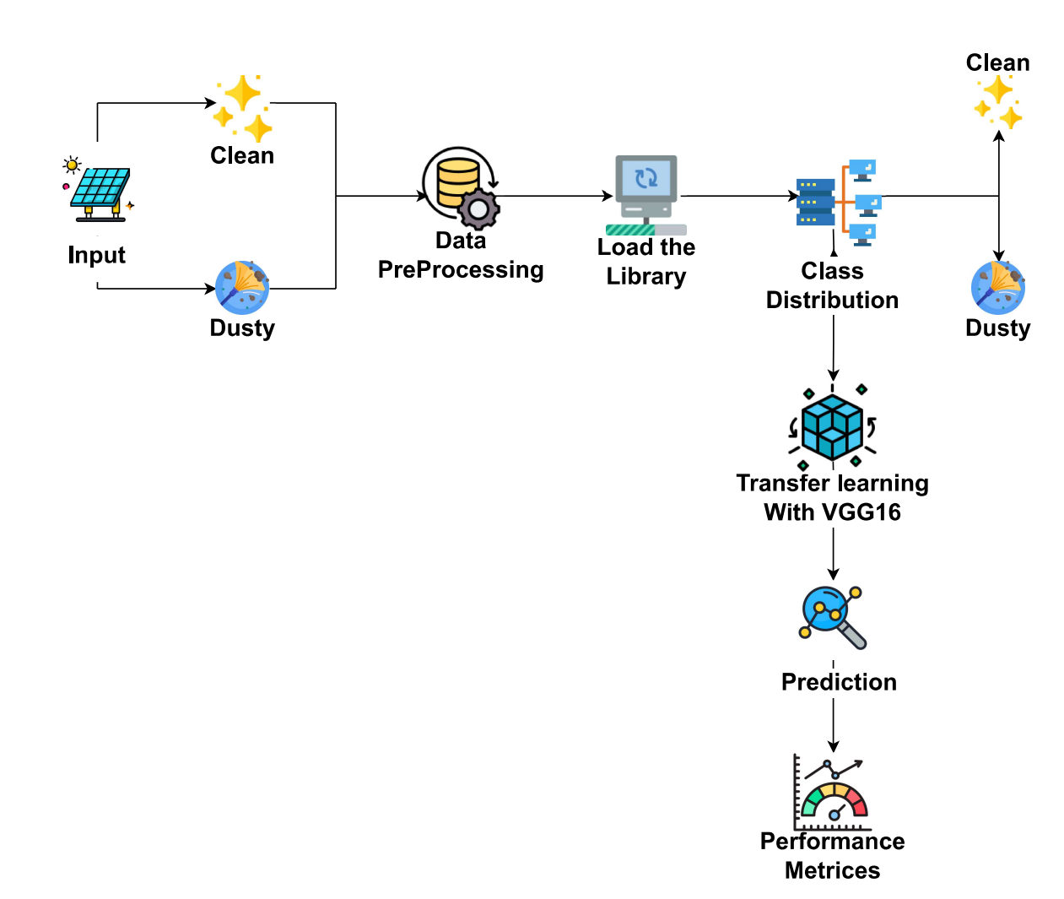

**Fig. 1. Architectural diagram for solar dust detection**

The resizing process entails scaling each image to fit within the specified dimensions, ensuring dataset uniformity. This uniformity mitigates distractions arising from variations in image size, enabling the model to concentrate solely on intrinsic fault patterns.

Moreover, standardizing image dimensions streamlines the training process by reducing computational complexity. Models trained on consistently sized images are more efficient and demand fewer computational resources during both the training and inference stages. Additionally, resizing images to a fixed dimension aids in generalization.

In summary, image resizing serves as a crucial preprocessing step, pivotal in improving the performance and robustness of machine learning models, particularly in computer vision tasks such as solar fault detection. By enforcing uniform image dimensions, this technique ensures the model's focus remains on relevant features necessary for accurate fault identification, resulting in more dependable and effective detection systems.

**C. Feature Extraction**

In the domain of machine learning, data splitting stands as a foundational technique utilized to ensure the efficacy of model training and evaluation. This method entails dividing the dataset into distinct subsets, each serving a specific role within the machine learning workflow. The primary objectives of data splitting encompass averting overfitting, enhancing model generalization, and accurately assessing model performance on unseen data.

Overfitting poses a prevalent challenge in machine learning, wherein a model excessively memorizes the training data in place of discerning and generalizing understanding the patterns and relationships. When a model overfits, it demonstrates great performance on the training data but struggles to generalize effectively to the novel, un-seen data instances. This phenomenon undermines the model's performance and reliability in real-world scenarios.

By employing data splitting, practitioners mitigate the risk of overfitting by restricting the model's access to the entire dataset during training. Typically, the dataset is partitioned into three primary subsets:

* **Training set**: The training set contains the largest segment of the dataset and is used for training the model parameters. Through respective learning from the training data, the model refines its parameters to minimize prediction errors.
* **Validation set**: The training set serves as a bridge between the training and testing sets. The validation set is used to observe the model’s performance during training and to fine tune hyper-parameters, preventing overfitting.
* **Testing set**: The test set is kept separate during training and is only used to assess the model's final performance on new, unseen data. It offers an impartial evaluation of how well the model can generalize to real-world situations.

In the specific context of image training, data splitting assumes heightened significance. Without meticulous partitioning of the dataset, the model may inadvertently fixate on the specific image. features or noise rather than extracting meaningful patterns. Through the utilization of training, validation, and test sets, practitioners can facilitate the training of models that adeptly discern the underlying features of images, consequently leading to enhanced performance and generalization on unseen data.

Using the below strategy, the dataset is divided as 70% to the training set and the rest 30% for validation. The split ensured that the model received sufficient training data while also having a dedicated set for monitoring overfitting and tuning hyperparameters.

In the first model, a pre-trained VGG16 is used as the base for fault detection. This architecture consists of multiple convolutional layers, pooling layers, and fully connected layers, each with its own set of parameters.

The convolutional layers in the models extract features from the input thermal images. These features represent the patterns and textures within the images that are relevant for fault detection. Each convolutional layer has a set of learnable parameters, including the weights and biases associated with its filters. The learnable parameters in this layer are weights and biases. The total number of convolutional layers present in this model is thirteen (13) with a stride size of 1.

The pooling layers reduce the spatial dimensions of the feature maps while retaining the important features, using biases as learning parameters. This reduction in dimensionality helps manage the model's computational complexity and minimizes the risk of overfitting. Each pooling layer has a set of parameters that determine the pooling size and stride. The number of pooling layers present here is five (5) with a stride size of 2. The fully connected layers in the model integrate the extracted features and learn a nonlinear mapping to the output classification labels. These layers also have a set of learnable parameters, including the weights and biases associated with the connections between neurons. and they are three (3) in number.

**Table I. Overview of the architecture – VGG16 CNN**

|  |  |  |
| --- | --- | --- |
| Layer(Type) | Output Shape | Param# |
| Vgg16(Functional) | (None,7,7,512) | 14,714,688 |
| flatten(Flatten) | (None,25088) | 0 |
| dense(Dense) | (None,256) | 6,422,784 |
| dropout(Dropout) | (None,256) | 0 |
| Dense_1(Dense) | (None,2) | 514 |

**Total Params**: 21,137,986 (80.64 MB)

**Trainable Params**: 6,423,298 (24.50 MB)

**Non-TrainableParams**:14,714,688 (56.13 MB)

The architectural design comprises 13 convolutional layers, each utilizing a stride size of (1,1). Subsequently, a global average pooling layer and a dropout layer are incorporated. Furthermore, a sole fully connected layer is integrated within the architecture.

During training, the model's parameters are adjusted using optimization algorithms such as Adam or stochastic gradient descent (SGD). The purpose of these algorithms is to minimize the loss function, which quantifies the difference between the model's predictions and the actual labels. This process involves iteratively refining the patterns and features related to different fault types in solar panels.

**D. Classification**

In the classification process, convolutional layers play a important role in extracting essential features from input thermal images. These features capture intricate patterns and distinct characteristics associated with different types of faults present in the images. As data traverses through convolutional, pooling, and fully connected layers, these features undergo gradual transformation and integration.

The final fully connected layer in the architecture holds significant importance as it serves as the cornerstone of classification. Here, the extracted features are synthesized and fused to create a comprehensive representation of the input image. This layer performs a weighted summation of these features, generating a vector of values corresponding to the probabilities assigned to each fault category. The use of the Sigmoid activation function further enhances this process. By normalizing output values into a probability distribution, the sigmoid function ensures that the model's predictions accurately represent the likelihood of each fault category for the given input image. Essentially, it yields a probability distribution over fault categories, offering insights into the relative probabilities of different fault types within the image.

Through an iterative process of feature extraction, transformation, and classification, the model proficiently discerns and distinguishes between various fault types depicted in thermal images. This sophisticated mechanism enables the model to be informed. decisions based on observed patterns, thereby facilitating precise fault detection and classification.

**V. RESULTS AND DISCUSSION**

The code we used here is a comprehensive workflow for training a deep learning model using the VGG16 architecture for image classification of solar panels into two categories: "Clean" and "Dusty". Here's a detailed explanation of the various components.

**1. Data Preprocessing:**

Dataset: The data is loaded from two directories (‘base_dir1’ and ‘base_dir2’) containing images of clean and dusty solar panels.

Splitting Data: The images are split into training (70%), testing, and validation (each 15%). This ensures that the model has data for training and is evaluated on unseen test and validation data.

File Handling: The code uses ‘os’ and ‘shutil’ to manage directories and copy files into appropriate folders.

**2. Image Data Generators:**

Data Augmentation: For the training data, an ‘Image Data Generator’ is used with augmentation techniques like rescaling, rotation, and zoom to make the model more robust and generalize well on unseen data.

Test and Validation Generators: These only rescale the pixel values without augmentation, ensuring that model evaluation occurs on original images.

**3. VGG16 Model Initialization:**

Transfer Learning: The model uses the pre-trained VGG16 architecture (without the fully connected layers) to leverage its feature extraction capability. The weights are frozen (i.e., not updated) to retain pre-learned features.

Custom Layers: After the VGG16 layers, new layers are added:

* A ‘Flatten’ layer is used to convert the feature maps into a 1D vector.
* A ‘Dense’ layer contains 256 neurons and ReLU activation.
* A ‘Dropout’ layer (50%) to reduce overfitting.

A final output layer with 2 neurons (one for each class), using the Sigmoid activation to predict probabilities.

**4. Class Weights for Imbalanced Data:**

The ‘compute_class_weight’ function calculates class weights to address class imbalance, ensuring that the model doesn't become biased toward the majority class ("Clean") during training. This helps the model give appropriate attention to minority classes.

**5. Training the Model:**

The model is trained for 50 epochs using the training and validation data, with the calculated class weights applied to account for imbalance. Early stopping is also implemented to avoid overfitting if validation performance doesn't improve.

**6. Evaluation:**

After training, the model is evaluated on the test data to check its generalization capability. The test accuracy achieved is approximately 97%, indicating very good performance.

**7. Visualization:**

Training and Validation Accuracy & Loss: The code plots the training and validation loss and accuracy over the epochs to assess the model’s learning process.

Predictions on Test Images: A batch of test images is visualized with their actual and predicted labels. If the prediction matches the actual label, the title is displayed in green; otherwise, it’s in red.

This workflow allows the user to preprocess image data, perform transfer learning using VGG16, and visualize the model's performance on test data effectively.

**Table II. Training and validation performance of VGG models**

|  |  |  |  |  |
| --- | --- | --- | --- | --- |
| **Models** | **Training**  **Accuracy**  **(%)** | **Training**  **Loss** | **Validation**  **Accuracy**  **(%)** | **Validation**  **Loss** |
| VGG13 | 75.93% | 0.4947 | 79.92% | 0.4605 |
| VGG16 | 98.89% | 0.1072 | 95.97% | 0.4000 |
| VGG19 | 94.31% | 0.1104 | 92.34% | 0.4193 |

**Fig. II. Training, validation values of VGG models**

The table summarizes the performance of VGG13, VGG16, and VGG19 models on solar dust detection dataset.

The models were evaluated based on their training and validation accuracy and loss. The results indicate that VGG16 and VGG19 consistently outperform VGG13, demonstrating higher accuracy and lower loss on both training and validation sets.

**Table III.** **Testing performance of VGG models**

|  |  |  |
| --- | --- | --- |
| **Models** | **Test**  **Accuracy (%)** | **Test**  **Loss** |
| VGG13 | 80.90% | 0.4535 |
| VGG16 | 97% | 0.1154 |
| VGG19 | 93.63% | 0.3612 |

**Fig. III VGG testing performance**

The table presents the testing performance of VGG13, VGG16, and VGG19 models on solar panel dust dataset**.** The models were evaluated based on their testing accuracy and loss. The results indicate that VGG16 and VGG19 consistently outperform VGG13, achieving higher accuracy and lower loss.

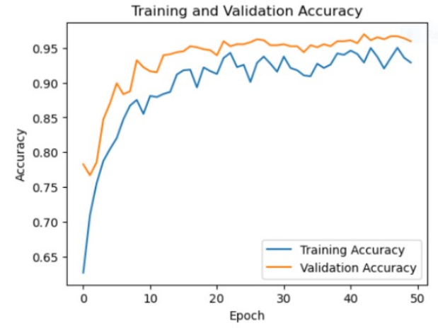

**Fig. IV. Training and validation loss curves for VGG16**

The model's learning efficiency across time (epochs) is shown. It indicates that overfitting may have occurred since validation loss stopped improving later on despite both training and validation loss having originally decreased.

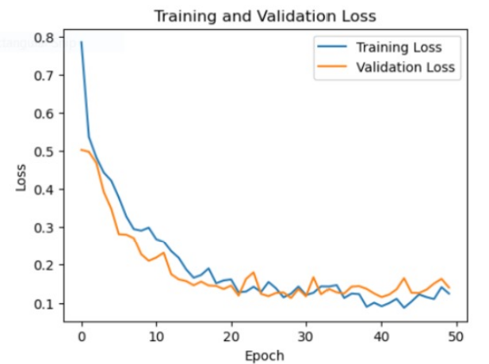

**Fig. V. Training and validation accuracy curves for VGG16**

The model's learning performance over time (epochs) is plotted. The accuracy of the validation and training data both increased at first, but the validation data eventually plateaued, suggesting possible overfitting. This implies that methods such as early stopping or regularization are necessary.

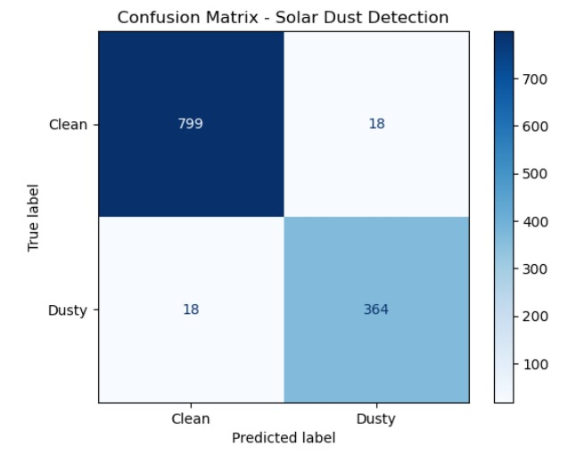

**Fig. VI. Confusion matrix for solar dust detection**

The confusion matrix visualizes the performance of the model for solar dust detection. The diagonal elements represent correctly classified instances (e.g., 799 clean samples correctly predicted as clean). Off-diagonal elements indicate misclassifications (e.g., 18 clean samples incorrectly predicted as dusty). The overall accuracy and other metrics can be calculated from the matrix to assess the model's effectiveness.

**Table IV. Classification report for solar dust detection**

|  |  |  |  |  |
| --- | --- | --- | --- | --- |
| **Class** | **Precision** | **Recall** | **F1-score** | **Support** |
| Clean | 95% | 96% | 96% | 529 |
| Dusty | 95% | 93% | 94% | 382 |
| Accuracy |  |  | 95% | 911 |
| Macro avg | 95% | 95% | 95% | 911 |
| Weighted avg | 95% | 95% | 95% | 911 |

The table above offers a detailed evaluation of the model's performance in detecting dust on solar panels.

Precision represents the proportion of correctly predicted instances for a class out of all instances labeled as that class. Recall measures the proportion of correct predictions for a class out of all actual instances of that class. The F1-score is the harmonic mean of precision and recall, providing a balanced measure of both. Support refers to the number of instances in each class. Additionally, the overall accuracy, macro average, and weighted average are provided to give a more comprehensive assessment of the model’s performance.

In the realm of sustainable energy, where solar panels play a key role, ensuring their optimal functionality is of paramount importance. With more than 51.428 billion solar panels globally the need for an accurate and efficient fault detection system is evident. This paper, aimed at enhancing the efficacy of solar panel fault detection, addresses a critical aspect of renewable energy infrastructure. By leveraging advanced technologies, specifically convolutional neural networks VGG16, architecture, this paper introduces a sophisticated model for identifying various faults in solar panels. The methodology involves a systematic approach, beginning with preparing and organizing a comprehensive dataset consisting of diverse instances of faulty solar panels.

Through the utilization of image processing techniques, the loaded images undergo preprocessing and feature extraction, laying the groundwork for the subsequent CNN-based analysis. On comparing the results, the VGG16 architecture could give a better accuracy of 95.4% dataset. One of the distinguishing features of this model is its ability to categorize faults beyond a binary classification, extending its proficiency to recognize specific types of faults, including bird-dropping, dust accumulation, physical damage, electrical damage, snow coverage, and clean panels. This nuanced approach provides valuable insights for maintenance and intervention strategies in solar panel installation.

**Prediction:**

Input image for prediction

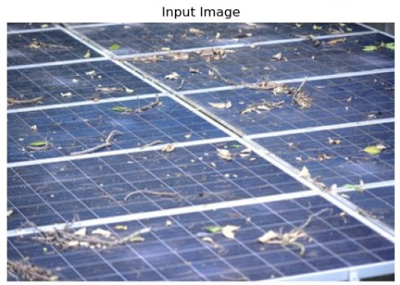

The image to be of a dusty solar panel array. The solar panels are covered in dirt, leaves, and debris, which can reduce their efficiency. The panels are arranged in rows.

The output analyzed for the input image

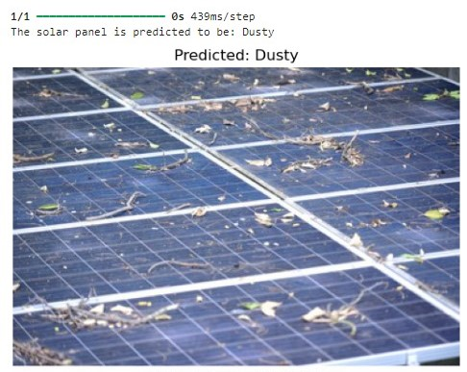

This image shows a solar panel array with a prediction overlay. The prediction states that the solar panel is "Dusty". The overlay also includes the following information:

* **1/1:** This likely indicates that only one panel was analyzed in this instance.
* **0s 439ms/step:** This refer to the processing time for each step of the analysis.

In summary, the VGG16 model is likely being used to analyze the solar panel image because of its ability to learn complex visual patterns and its success in image classification tasks.

1. **CONCLUSION AND FUTURE WORK**

In this article, we developed a solar panel image classification system to distinguish between "Clean" and "Dusty" solar panels using a Convolutional Neural Network (CNN) based on the VGG16 architecture. By leveraging transfer learning with pre-trained ImageNet weights, we utilized VGG16 as a feature extractor, allowing the model to benefit from previously learned image features. This approach reduced training time and provided a strong starting point for the classification task. The dataset consisted of two classes, "Clean" and "Dusty," with significant class imbalance. To address this, class weights were applied during model training. Additionally, data augmentation techniques were used to enhance the model's robustness.

The model achieved a test accuracy of 95%, showing promising results for distinguishing between clean and dusty solar panels. The project also highlighted areas for potential improvement, including fine-tuning the pre-trained layers, expanding the dataset, optimizing hyperparameters, and integrating additional features.

Future systems could integrate IoT-enabled cameras mounted on solar farms to continuously monitor panels in real-time. This would allow for automated, high-frequency image capturing to detect dust and other obstructions, improving the timeliness of detection.

By combining the classification system with an automated cleaning mechanism (such as robotic cleaners or water sprayers), the model could trigger cleaning processes whenever a panel is detected as "Dusty". This would lead to a fully automated solution for solar panel maintenance, significantly reducing manual intervention and maintenance costs.

1. **REFERENCES**

[1] Z. Huang, S. Duan, F. Long, Y. Li, J. Zhu and Q. Ling, "Fault Diagnosis for Solar Panels using Convolutional Neural Network," 2021 33rd Chinese Control and Decision Conference (CCDC), Kunming, China, pp. 153-158, 2021.

[2] M. Alsafasfeh, I. Abdel-Qader and B. Bazuin, "Fault detection in photovoltaic system using SLIC and thermal images," 2017 8th International Conference on Information Technology (ICIT), Amman, Jordan, pp. 672-676, 2017.

[3] N. Padmavathi, A. Chilambuchelvan, “Fault Detection and Identification of Solar Panels using Blueetoth”, International Conference on Energy, Communication, Data Analysis on Soft Computing (ICECDS), pp. 3420-3426 , 2017.

[4] G. Terzoglou, M. Loufakis, P. Symeonidis, D. Ioannidis and D. Tzovaras, "Employing deep learning framework for improving solar panel defects using drone imagery," 2023 24th International Conference on Digital Signal Processing (DSP), Rhodes (Rodos), Greece, pp. 1-5, 2023.

[5] S. H. Han, T. Rahim and S. Y. Shin, "Detection of Faults in Solar Panels Using Deep Learning," 2021 International Conference on Electronics, Information, and Communication (ICEIC), Jeju, Korea (South), pp. 1-4, 2021.

[6] Monica Patil, B. Praveen Kumar, Natarajan Karuppiah, “Detection and Location of Faults in Photo Voltaic Systems”, 2nd International Conference on Smart Technologies and Systems for Next Generation Computing (ICSTSN),ICSTSN7873.2023.10151647, 2023.

[7] H. Bendale, H. Aswar, H. Bamb, P. Desai and C. N. Aher, "Deep Learning for Solar Panel Maintenance: Detecting Faults and Improving Performance," 2023 14th International Conference on Computing Communication and Networking Technologies (ICCCNT), Delhi, India, pp. 1-5,2023.

[8] M. Pa, M. N. Uddin and A. Kazemi, "A Fault Detection Scheme Utilizing Convolutional Neural Network for PV Solar Panels with High Accuracy," 2022 IEEE 1st Industrial Electronics SocietyAnnual On-Line Conference (ONCON), kharagpur, India, 2022, pp. 1-5.

[9] N. Prajapati, R. Aiyar, A. Raj and M. Paraye, "Detection and Identification of faults in a PV Module using CNN based Algorithm," 2022 3rd International

Conference for Emerging Technology (INCET), Belgaum, India, 2022, pp. 1-5.

[10] B. Sandeep, D. S. Reddy, A. R and R. Mahalakshmi, "Monitoring of PV Modules and Hotspot Detection using TensorFlow," 2022 International Conference on Electronics and Renewable Systems (ICEARS), Tuticorin, India, 2022, pp. 155- 160.

[11] Shivalila. H, Neelima. N, Tripty Singh, “Face detection and Recognition using Face Mesh and Deep Neural Networks”, Procedia Computer Science, vol.218, pp: 741-749, 2023.

[12] O. N. Teja, M. S. Ramakrishna, G. B. Bhavana and K. Sireesha, "Fault Detection and Classification in Power Transmission Lines using Back Propagation Neural Networks," 2020 International Conference on Smart Electronics and Communication (ICOSEC), Trichy, India, 2020, pp. 1150-1156.

[13] Neelima.N., E.Sreenivasa Reddy, “An efficient approach to CBIR using DWT and Quantized histogram”, Int. Journal of Innovative Computing, Information and Control, IJICIC (ScopusQ1), vol.13, No.1, pp:157-166, (2017).